Nama : Tony Afriyanto

Nim : 20180801323

Jurusan : teknik informatika

Mata kuliah : BASIS DATA

**REVIEW UTS DATABASE ORACLE**

Hubungan antar entity, Primary key, dan Foreign key dari ke 5 tabel dan Menggunakan syntax query dari Pak Mazmur Tarigan

|  |
| --- |
| Product |
| Product ID (PK) |
| Product Name |
| Category |
| Buy Price |
| Sell Price |
| Product Image |
| Description |

|  |
| --- |
| Order |
| Order No (PK) |
| Customer (FK) |
| Date |
| Is Deliver |

|  |
| --- |
| Stock |
| Product Name (FK) |
| Quantity |
| Date |
| Stock By |

|  |
| --- |
| Order Details |
| Order No (PK) |
| Product Name (FK) |
| Quantity |

|  |
| --- |
| Customer |
| Cust ID (PK) |
| First Name |
| Middle Name |
| Last Name |
| Shipping Address |
| Email |
| Contact |

**QUERY**

% Menampilkan dan melihat deskripsi 5 table yang sudah dibuat sesuai perintah di papan tulis %

SELECT * FROM PRODUCT_NOV

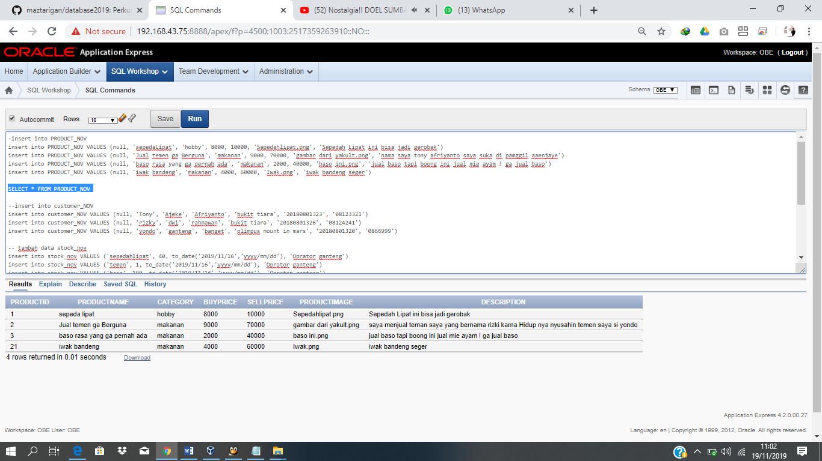

SELECT * FROM ORDER_NOV

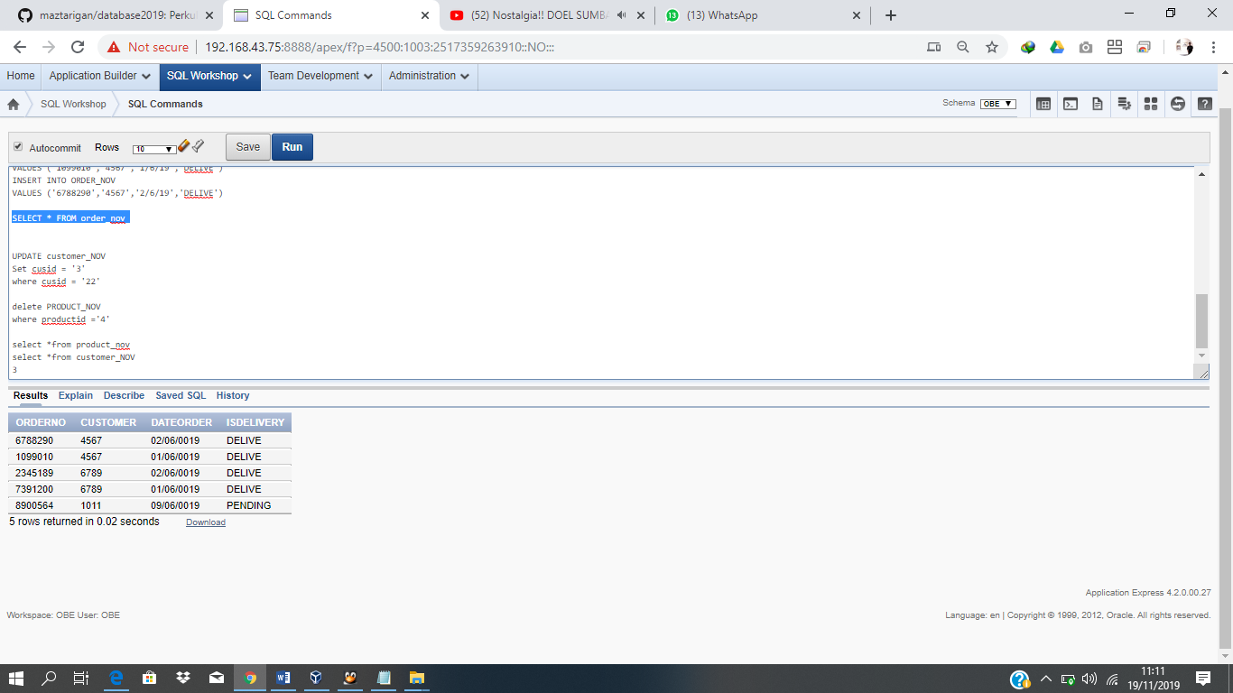

SELECT * FROM CUSTOMER_NOV

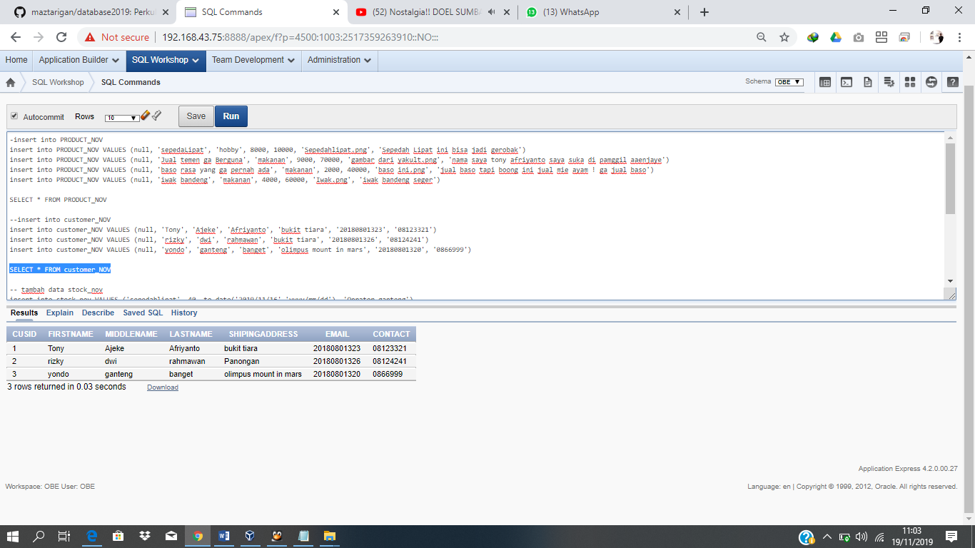

SELECT * FROM ORDER_DETAILS_NOV

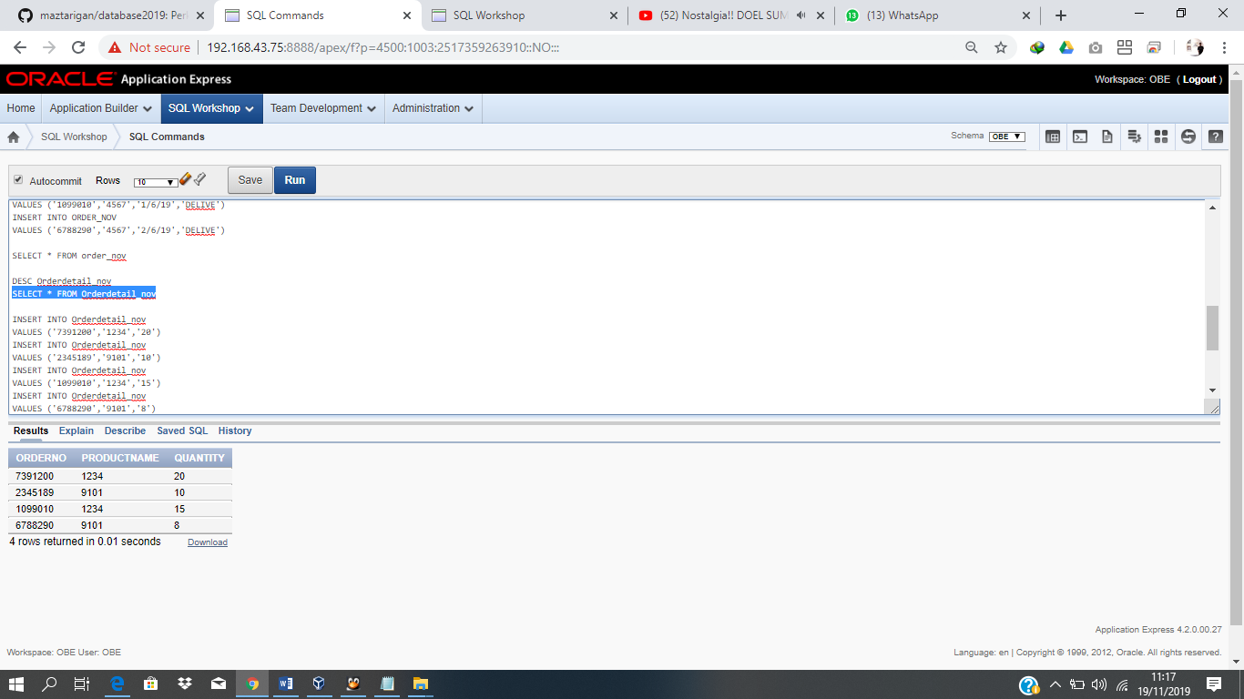

SELECT * FROM STOCK_NOV

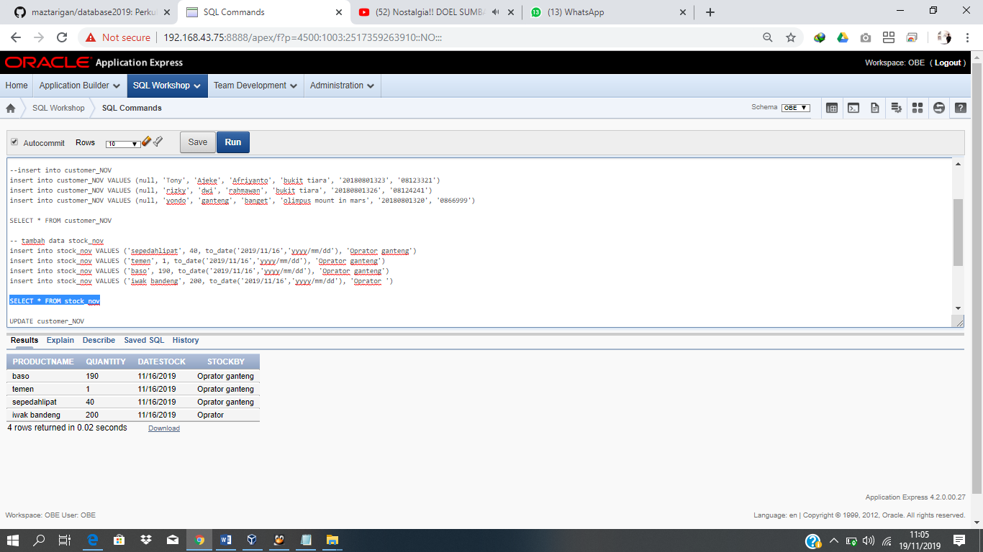

DESC PRODUCT_NOV

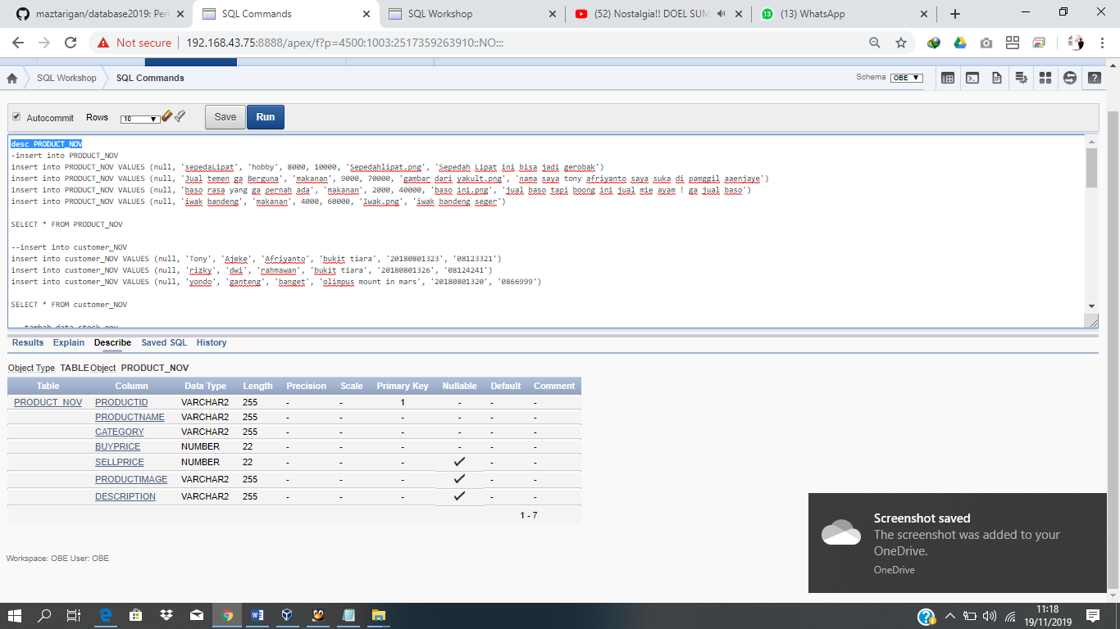

DESC ORDER_NOV

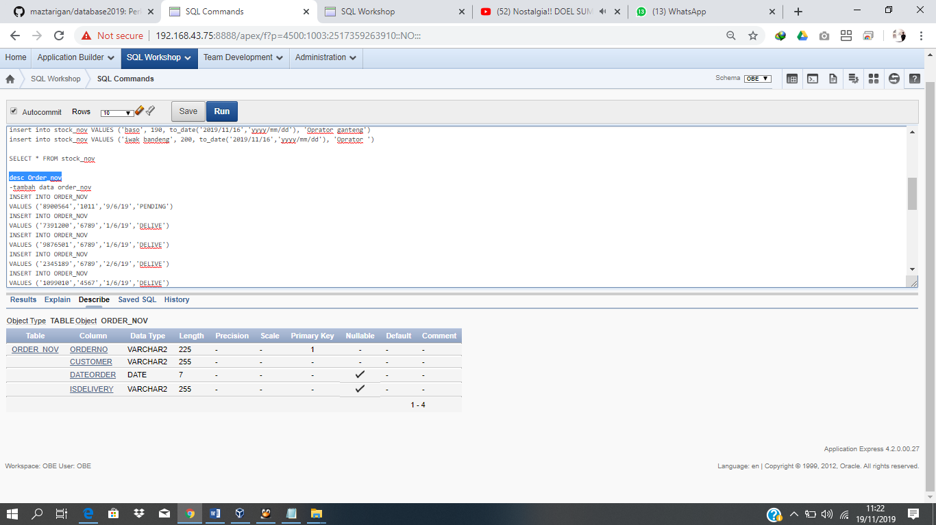

DESC CUSTOMER_NOV

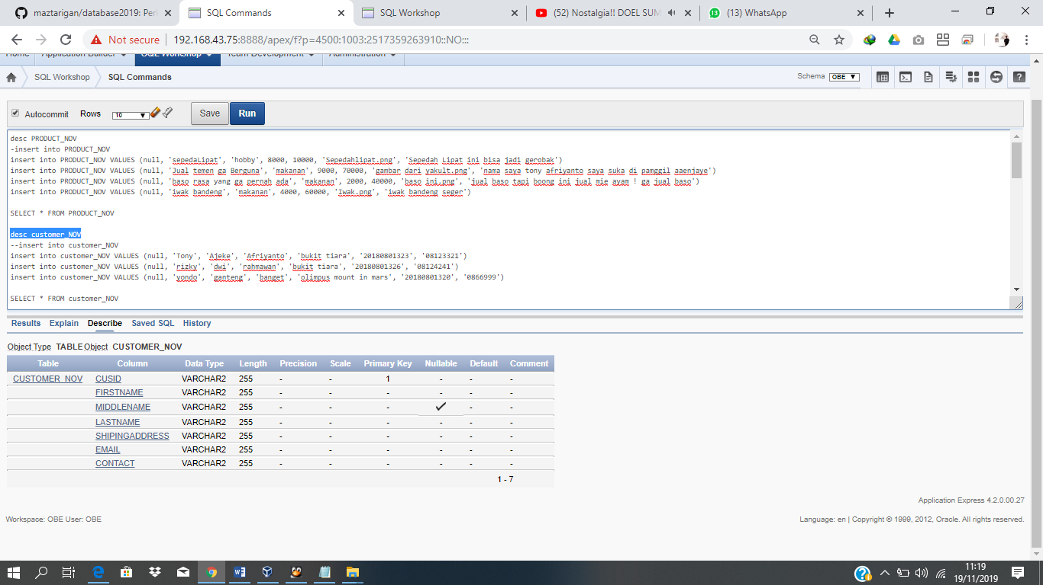

DESC ORDER_DETAILS_NOV

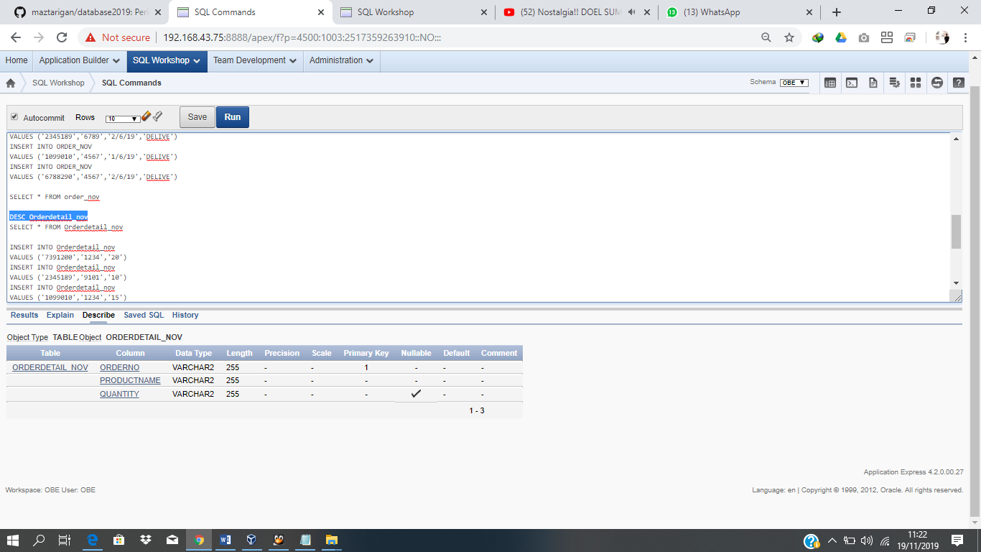

DESC STOCK_NOV

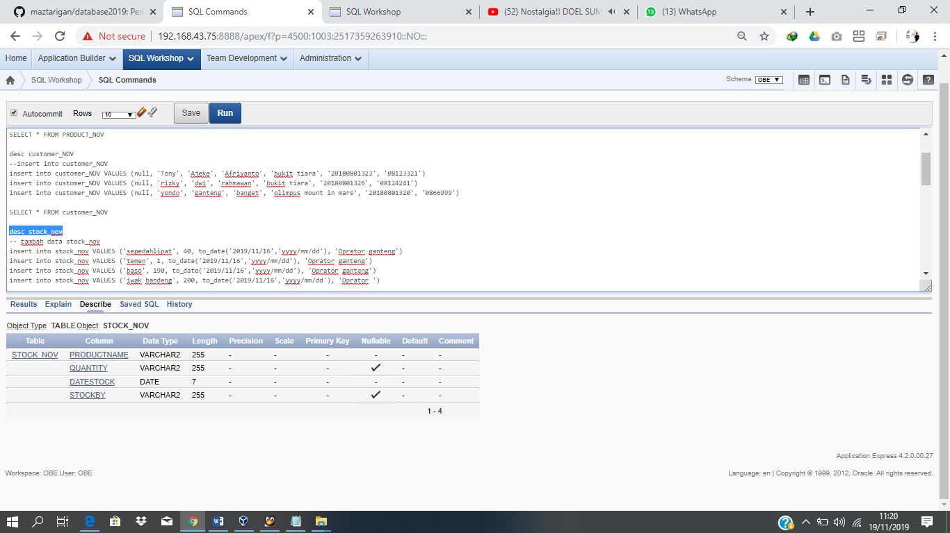

// --- //

**SOAL NO 6**

**TAMPILKAN DATA TRANSAKSI**

**SELECT** A.ORDER_NO, A.DATE, C.FIRST_NAME, B.PRODUCT_NAME, B.QUANTITY, D.SELL_PRICE, B.QUANTITY*D.SELL_PRICE **AS TOTAL**

**FROM** ORDER_NOV A, ORDER_DETAILS_NOV B, CUSTOMER C, PRODUCT D

**WHERE** B.ORDER_NO = A.ORDER_NO AND **C.CUST_ID = A.CUSTOMER** AND D.PRODUCT_NAME = B.PRODUCT_NAME

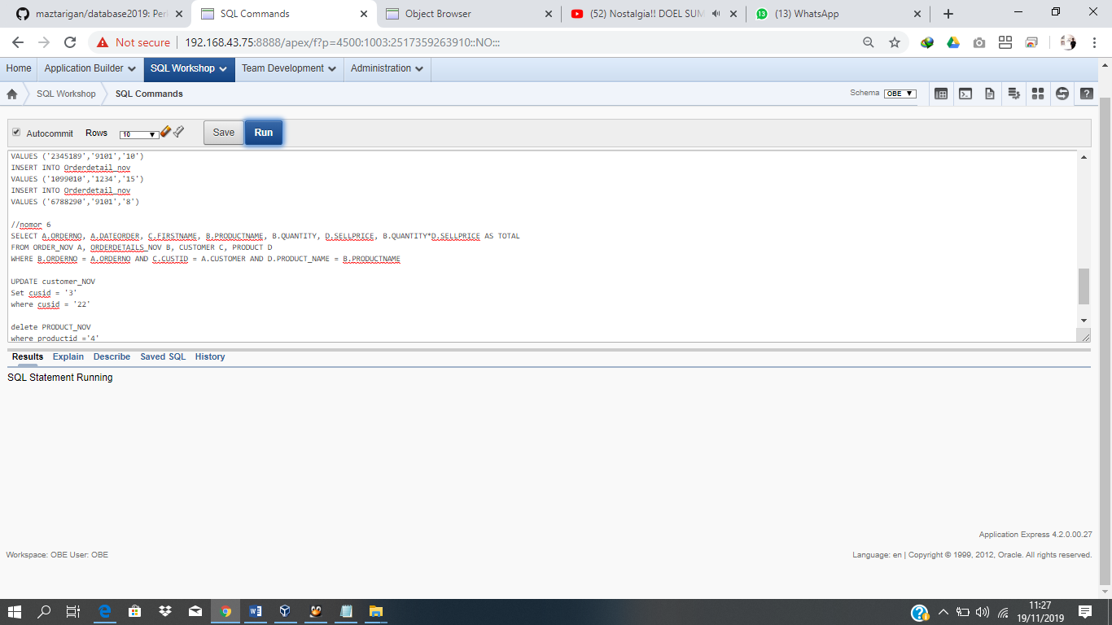

// --- //

**SOAL NO 7**

**TAMPILKAN PRODUK TERBANYAK DIJUAL**

**SELECT** PRODUCT_NAME, SUM(QUANTITY)

**FROM** ORDER_DETAILS_NOV

**GROUP BY** PRODUCT_NAME, QUANTITY

**ORDER BY** QUANTITY DESC

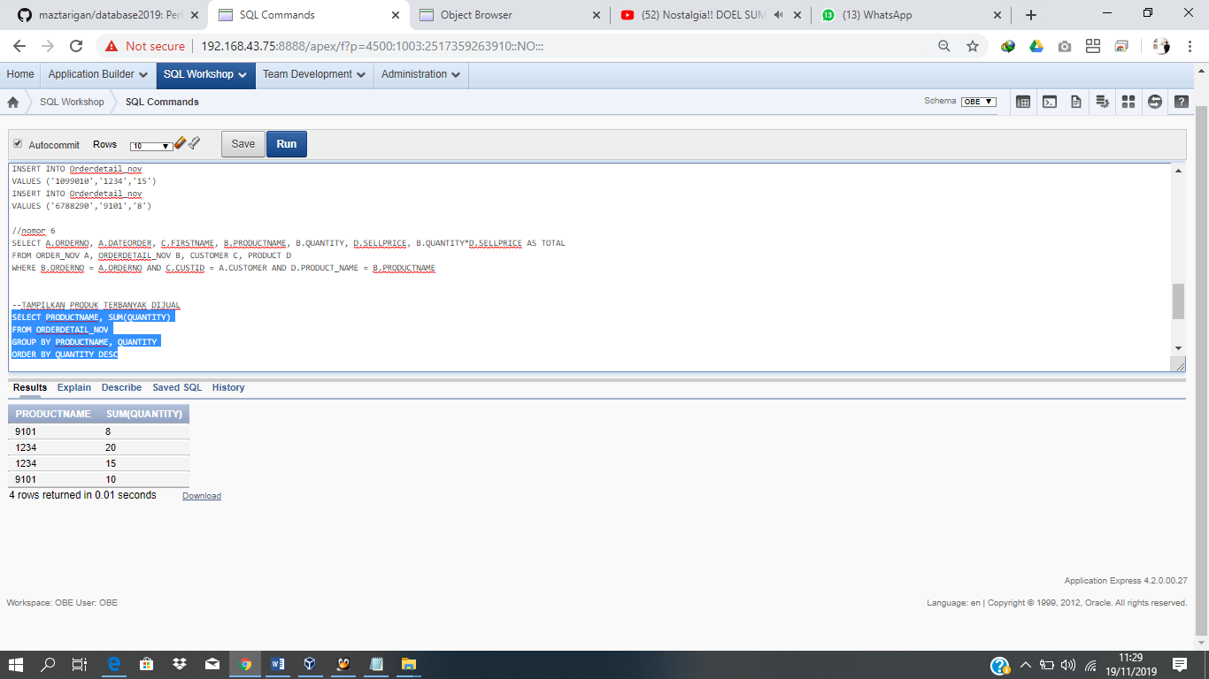

// --- //

**SOAL NO 8**

**TAMPILKAN PRESENTASI PENJUALAN TIAP HARI UNTUK MASING-MASING PRODUK**

**SELECT** A.DATE, B.PRODUCT_NAME, SUM(B.QUANTITY),

PERSENTASE = (SUM(B.QUANTITY)/

SELECT SUM(D.QUANTITY)

FROM ORDER_NOV C, ORDER_DETAILS_NOV D

WHERE D.ORDER_NO = C.ORDER_NO AND C.DATE = '2019-11-16')*100

**FROM** ORDER_NOV A, ORDER_DETAILS_NOV B

**WHERE** B.ORDER_NO = A.ORDER_NO AND A.DATE = '2019-11-16'

**GROUP BY** A.DATE, B.PRODUCT_NAME, B.QUANTITY

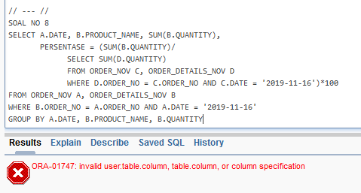

* Syntax pada saat mengerjakan

desc PRODUCT_NOV

-insert into PRODUCT_NOV

insert into PRODUCT_NOV VALUES (null, 'sepedaLipat', 'hobby', 8000, 10000, 'Sepedahlipat.png', 'Sepedah Lipat ini bisa jadi gerobak')

insert into PRODUCT_NOV VALUES (null, 'Jual temen ga Berguna', 'makanan', 9000, 70000, 'gambar dari yakult.png', 'nama saya tony afriyanto saya suka di pamggil aaenjaye')

insert into PRODUCT_NOV VALUES (null, 'baso rasa yang ga pernah ada', 'makanan', 2000, 40000, 'baso ini.png', 'jual baso tapi boong ini jual mie ayam ! ga jual baso')

insert into PRODUCT_NOV VALUES (null, 'iwak bandeng', 'makanan', 4000, 60000, 'Iwak.png', 'iwak bandeng seger')

SELECT * FROM PRODUCT_NOV

desc customer_NOV

--insert into customer_NOV

insert into customer_NOV VALUES (null, 'Tony', 'Ajeke', 'Afriyanto', 'bukit tiara', '20180801323', '08123321')

insert into customer_NOV VALUES (null, 'rizky', 'dwi', 'rahmawan', 'bukit tiara', '20180801326', '08124241')

insert into customer_NOV VALUES (null, 'yondo', 'ganteng', 'banget', 'olimpus mount in mars', '20180801320', '0866999')

SELECT * FROM customer_NOV

desc stock_nov

-- tambah data stock_nov

insert into stock_nov VALUES ('sepedahlipat', 40, to_date('2019/11/16','yyyy/mm/dd'), 'Oprator ganteng')

insert into stock_nov VALUES ('temen', 1, to_date('2019/11/16','yyyy/mm/dd'), 'Oprator ganteng')

insert into stock_nov VALUES ('baso', 190, to_date('2019/11/16','yyyy/mm/dd'), 'Oprator ganteng')

insert into stock_nov VALUES ('iwak bandeng', 200, to_date('2019/11/16','yyyy/mm/dd'), 'Oprator ')

SELECT * FROM stock_nov

desc Order_nov

-tambah data order_nov

INSERT INTO ORDER_NOV

VALUES ('8900564','1011','9/6/19','PENDING')

INSERT INTO ORDER_NOV

VALUES ('7391200','6789','1/6/19','DELIVE')

INSERT INTO ORDER_NOV

VALUES ('9876501','6789','1/6/19','DELIVE')

INSERT INTO ORDER_NOV

VALUES ('2345189','6789','2/6/19','DELIVE')

INSERT INTO ORDER_NOV

VALUES ('1099010','4567','1/6/19','DELIVE')

INSERT INTO ORDER_NOV

VALUES ('6788290','4567','2/6/19','DELIVE')

SELECT * FROM order_nov

DESC Orderdetail_nov

SELECT * FROM Orderdetail_nov

INSERT INTO Orderdetail_nov

VALUES ('7391200','1234','20')

INSERT INTO Orderdetail_nov

VALUES ('2345189','9101','10')

INSERT INTO Orderdetail_nov

VALUES ('1099010','1234','15')

INSERT INTO Orderdetail_nov

VALUES ('6788290','9101','8')

//nomor 6

SELECT A.ORDERNO, A.DATEORDER, C.FIRSTNAME, B.PRODUCTNAME, B.QUANTITY, D.SELLPRICE, B.QUANTITY*D.SELLPRICE AS TOTAL

FROM ORDER_NOV A, ORDERDETAIL_NOV B, CUSTOMER C, PRODUCT D

WHERE B.ORDERNO = A.ORDERNO AND C.CUSTID = A.CUSTOMER AND D.PRODUCT_NAME = B.PRODUCTNAME

--TAMPILKAN PRODUK TERBANYAK DIJUAL

SELECT PRODUCTNAME, SUM(QUANTITY)

FROM ORDERDETAIL_NOV

GROUP BY PRODUCTNAME, QUANTITY

ORDER BY QUANTITY DESC

UPDATE customer_NOV

Set cusid = '3'

where cusid = '22'

delete PRODUCT_NOV

where productid ='4'

select *from product_nov

select *from customer_NOV